Demonstrative Attribute

✅ What is Demonstrative Attribute?
# Source: AI Source: Provided by: [Data Path: Persons Table -> ID Column: 1, Name_En Column: Motasem Essam] -> From: [Chatgpt (GPT‑5 Mini)] on [8/7/2025]
A Demonstrative Attribute is a demonstrative determiner (like this, that, these, those) used before a noun to specify which person or thing is being referred to. It functions attributively, modifying a noun directly.

🔹 Key Features:
# Source: AI Source: Provided by: [Data Path: Persons Table -> ID Column: 1, Name_En Column: Motasem Essam] -> From: [Chatgpt (GPT‑5 Mini)] on [8/7/2025]
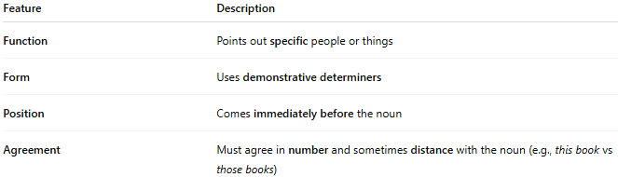
Feature | Description
Function | Points out specific people or things
Form | Uses demonstrative determiners
Position | Comes immediately before the noun
Agreement | Must agree in number and sometimes distance with the noun (e.g., this book vs those books)

🔹 Demonstrative Words Used as Attributes:
# Source: AI Source: Provided by: [Data Path: Persons Table -> ID Column: 1, Name_En Column: Motasem Essam] -> From: [Chatgpt (GPT‑5 Mini)] on [8/7/2025]
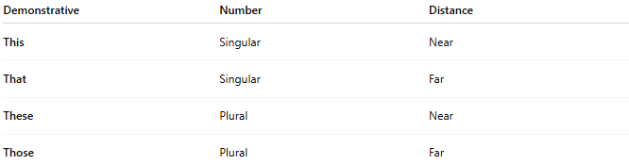
Demonstrative | Number | Distance
This | Singular | Near
That | Singular | Far
These | Plural | Near
Those | Plural | Far

🔹 Examples in Sentences:
# Source: AI Source: Provided by: [Data Path: Persons Table -> ID Column: 1, Name_En Column: Motasem Essam] -> From: [Chatgpt (GPT‑5 Mini)] on [8/7/2025]
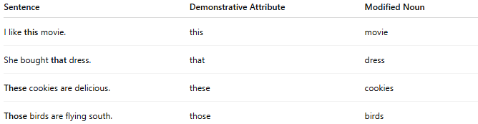
Sentence | Demonstrative Attribute | Modified Noun
I like this movie. | this | movie
She bought that dress. | that | dress
These cookies are delicious. | these | cookies
Those birds are flying south. | those | birds

🔹 Comparison with Other Attributes:
# Source: AI Source: Provided by: [Data Path: Persons Table -> ID Column: 1, Name_En Column: Motasem Essam] -> From: [Chatgpt (GPT‑5 Mini)] on [8/7/2025]
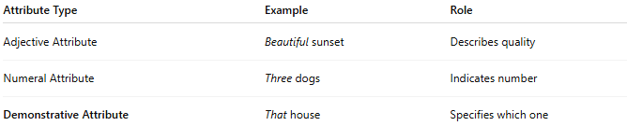
Attribute Type | Example | Role
Adjective Attribute | Beautiful sunset | Describes quality
Numeral Attribute | Three dogs | Indicates number
Demonstrative Attribute | That house | Specifies which one

